= List.Dates(#date(1998,5,23),365, #duration(1,0,0,0))

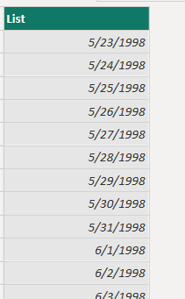

Here’s a breakdown of what #duration(1,0,0,0) means:

1: Represents the number of days.

0: Represents the number of hours.

0: Represents the number of minutes.

0: Represents the number of seconds.

= List.Times(#time(0,0,0),96,#duration(0,0,15,0))

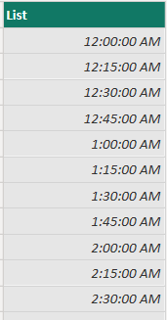

***Between two dates***

= List.Dates(#date(1998,5,23), Duration.Days(Date.From(DateTime.LocalNow()) - #date(1998,5,23)), #duration(1,0,0,0))

= List.DateTimes(#datetime(2022,1,1,0,0,0), 900, #duration(0,0,15,1))  
